**Jméno**: Daniel Slowik **Třída: 2.C Datum: 22/2/2019**

|  |
| --- |
| Evaluation  **%** |

číslo otázky

9

**Otázka- téma: My Daily Programme**

**Tři zajímavé úvodní věty k tématu:**

1. I usually get up at 6 o'clock.

2. I live in house with my family, but without my sister.

3. I go to school with my friend by bus everyday.

**Dvacet vhodných a tématu týkajících se slovíček**

|  |  |  |  |  |
| --- | --- | --- | --- | --- |
| School | Home | Walking | Bus | Friends |
| Family | Parents | Food | Hobbies | Ideas |
| Fun | Homeworks | News | Lunch | Harmonogram |
| Plans | Computer | Internet Friends | Talking | Learning |

**Vytvořte větu:**

**- větu v přítomném čase:** I study in Havířov.

**- v předpřítomném čase:** I haven‘t been in university yet.

**- v minulém čase:** In the morning I lost my keys.

**- podmínkovou větu:** When I have a free time, I usually play a computer games.

**Uveďte tři zajímavá souvětí k tématu:**

1. When parents are not home, I need to feed dog and ducks.

2. Before I can go to bed, I have to do the housework.

3. I often go to sleep at midnight, but sometimes I am so tired to keep it.

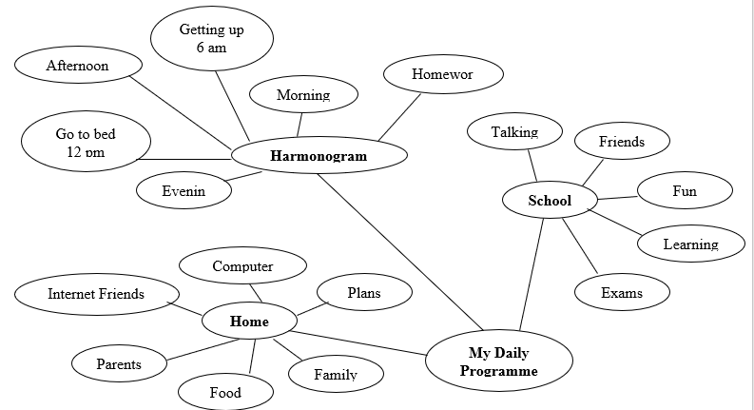**Mind map**